Seismic Induced Forces on Rigid Water Storage Tanks

S. H. Helou* Ph.D., P.E.

* Assistant Professor, Civil Engineering Department,

An-Najah National University, Nablus-Palestine

shhelou@yahoo.com

Abstract. Ubiquitous water storage tanks constructed of reinforced concrete are one popular and widely used component in any major water distribution network particularly for domestic water use. Structural engineers rely, at best, on finite element method program packages to solve for the structural parameters necessary for the design undertaking. In predominant instances a two dimensional formulation is still prevalent when seismic loadings are considered. Computer programs unless supplied by an adequate numerical model would give erroneous results especially when seismic forces are of due consideration. The following discourse presents a 3D structural modeling technique that accounts for the prescribed hydrodynamic pressure, indispensible for accurate evaluation of the induced forces on the outer shell; this is in line with ACI code requirement albeit these requirements are not clearly tailored for a 3D analysis. Furthermore, detailed study of the seismic parameters involved is conducted; this includes but is not limited to the kind and the number of modal modes involved and the associated aspect ratio of the tank. The discourse is limited to the common upright reinforced concrete circular cylindrical water storage tanks anchored and built on grade. This is tantamount to considering one mode shape of vibration leading to only one component of convective added mass. For quantifying the effect of support conditions the same tank model is modified to include select soil conditions modeled as area springs. The overall impact of support conditions on the overall behavior of the structure is of a magnitude to be reckoned with.

Keywords: Storage Tanks, Impulsive Pressure, Convective Pressure, Structural Modeling, Hydrodynamic Forces.

- Introduction:

Prior to the advent of modern computers and the widespread of numerical methods in structural engineering, water storage tanks were analyzed mathematically using closed form shell analysis solution together with some relevant design curves. Such procedures usually deal with uncovered storage tanks subject to hydrostatic forces; the procedure is opted for due to the ease of the associated computations yet seldom, if ever, complex seismic forces are thoroughly considered. Water effects are therefore traditionally limited to hydrostatic effects. Rigorous evaluation of the dynamically induced stresses on the tank’s wall is a complex undertaking as it involves, inter alias, the interaction between the lateral displacement of the tank’s wall and that of the fluid motion albeit in rigid tanks this effect is less pronounced. The following illustration clearly shows how major finite element programs are indeed capable to accurately carry out the computational exercise provided that the mechanical model is properly established.

Moreover, field experience shows that reinforced concrete tanks enjoy utterly different behavior than flexible steel tanks. While the former types can develop enormous stresses that lead to cracking and leakage, thus are not prone to buckling, the later types fail by what is known as “elephant’s foot” buckling mode which is invoked by the significant beam like bending moments resulting from hydrodynamic forces; moreover the sloshing liquid may potentially damage the roof structural elements. The focus of the present analytic discourse is limited to lateral ground accelerations only, but with primary focus on the loading side of the seismic structural engineering undertaking.

Hydrodynamic forces are substantial under seismic action while the damping influence is lower than that of regular structures. Two widely separated periods govern the structural behavior during earthquake excitations; the sloshing frequency of the contained fluid which is very long and ranges from 6 to 10 sec whereas the coupled vibration modes of the elastic shell and the contained fluid have periods less than 1 second. Furthermore, tanks behavior is normally dictated by their general configuration and their aspect ratio; these are the variables that govern the governing characteristic value problem. Another major parameter that demands thorough investigation is the nature of the support conditions. A rigid foundation renders the structural behavior of water tanks quite different than of tanks built on an elastic foundation.

- Brief Review of the Codes of Practice
Of the best structural engineering design codes that tackle fluid tank systems are the American Concrete Institute, ACI 350.3, the Euro Code 8 and the Standards Association of New Zealand, NZS. These codes address ground supported circular and rectangular concrete tanks having fixed or flexible bases. This condition is relevant to the present discourse; the aim of which is to create a mechanical model suitable for presenting the vibrating fluid tank system by a proper spring mass system which considerably simplifies the undertaking. Proper seismic analysis accounts for the inertia forces of the accelerating structure as well as the inertia forces of the accelerating fluid which the tank contains. The ACI uses the mechanical model of Housner but with the generalizations introduced by Wozniak and Mitchel. The generalization introduced makes the model equally applicable for the short and stubby or for tall and slender tanks.

Euro Code 8 mentions the acceptable procedure of Valestos and Yang [Jaiswal et al, page 5] for modeling rigid water tanks. The guidelines of NZS are essentially similar to the Euro Code 8 but introduce a reduction factor for the mass of the tank’s wall in order to compensate for the conservatism in evaluating the impulsive force. Furthermore, when dealing with a rectangular tank it suggests using half of the width of the rectangular tank as a radius of an equivalent circular cylindrical tank. In regard to the combination procedure of the impulsive forces and the convective forces the ACI and NZS suggest the Square Root Sum of the Squares method (SRSS) while the Euro Code suggests the absolute sum combination. In the following example no load factors are applied as sectional design is not a prime objective of the present exercise.

Irrespective of the above cited codes of practice, there is no mention of the numerical modeling techniques using any of the presently available Finite Element Method packages. The manner of the added mass inclusion is either absent or left to the discretion of the analyst.

- Hydrodynamic Pressure Distribution:

Stresses within the walls of a vertical circular cylindrical liquid storage tank depend primarily on the distribution of the internal fluid pressure. For the static condition the stress distribution from the fluid at rest is linear and poses a trivial case study; such stresses follow a triangular distribution with the maximum value occurring at the base. However, when lateral ground excitation is of importance more involved considerations become indispensible. Hydrodynamic pressure distribution involves two components of pressure, one is called convective which is dependent on the sloshing frequency of water and the other is called impulsive which is proportional to the acceleration of the ground motion but independent of the frequency of the fluid motion. Both occur in addition to the hydrostatic pressure distribution. A presentation of such forces is shown in Figure 1. The impulsive component involves the volume of water at the bottom of the tank while the convective component involves the upper volume of the water because this is the region where the surface dynamic effects on the fluid motion are more pronounced. A number of investigators have solved such a mathematical problem for both the rigid tank case as well as the flexible tank case. The theoretical solution to such problems usually starts by assuming that the fluid is irrotational and inviscid thus the fluid motion is governed by Laplace’s Equation.

A brief summary of the mathematical formulation and the associated boundary conditions are included for clarity. The equations are written in a cylindrical coordinate system with its origin taken at the water surface but moving with the tank.

$∇^{2} Ф=0$ (1)
$$\frac{∂Ф}{∂r}=0 at r=r_{0} (2)$$
$$\frac{∂Ф}{∂z}=0 at z= -H (3)$$
$$P=-ρ \left\{\frac{∂Ф}{∂t} + {\ddot{X}}_{H}\left(t\right)r \cos{θ}+gz\right\} (4)$$

In which$Ф$ is the potential function, r₀ is the radius of the tank, H is the height of the fluid, g is the gravitational acceleration and${\ddot{X}}_{H}\left(t\right)$ is a ground acceleration function of time. The pressure term of equation 4, P is the generalized form of Bernoulli’s equation.

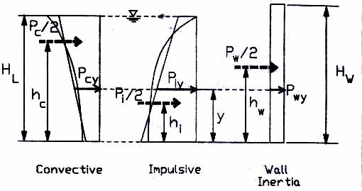

Figure 1: Impulsive and Convective Components of the Hydrodynamic Pressure,
[ACI 350.3-01. Figure R5.5]

- The Numerical Model

The following rigorous analysis is for an upright rigid tank which for convenience is arbitrarily selected to have a 12-meter diameter and a 7-meter height with 1 meter freeboard; a ratio of H/R<1.5 implies a relatively shallow tank. The present three-dimensional analysis is accomplished by SAP 2000.The total hydrodynamic pressure on the walls of liquid storage rigid tanks is expressed as an uncoupled summation of two components of pressure. They are:

- The impulsive component which represents the portion of the fluid that moves in unison with tank’s structure.
- The convective component which represents the effect of the sloshing action of the contained fluid.

For reinforced concrete water storage tanks which, for all practical purposes, are considered rigid, this amounts to a single degree of freedom system associated with the first eigenvector. The response of the entire system is unidirectional because of the inherent symmetry nature of cylindrical tanks. The walls of the selected concrete tank are modeled as shell elements of 20 cm thickness, while the roof is made up of 15 cm thick shell elements. The bottom of the storage tank is 30 cm thick and monolithic with the tank’s walls; this corresponds to type 2.1 in accordance with the cited ACI 350.3-01 classifications. The tank is assumed to have an importance factor, I=1. The subsequent analysis is based on the assumption that the tank is rigidly supported at the base. However, in order to study the effect of soil conditions the same model is further modified to include an elastic support; a soil base of site class B and having a bearing strength of 3Kg/cm².

A numerical model, by definition replaces the fluid-tank system by a spring- mass system which simplifies the evaluation of the structural response. In a fluid structure interaction problem a mechanical model representing the assemblage is devised. It includes, inter alias, the impulsive mass and the convective mass of the water as well as their respective heights together with the stiffness and the topology of the associated springs. Elastic foundations are represented by a system of area springs with proper stiffness that depends on the prevailing soil material parameters.

Following the ACI code requirements the impulsive component of the mass M_{I} is rigidly attached to the tank at a height of h_{I} while the convective component is M_{C} acts at a height h_{c} and is attached to the tank walls by springs of finite stiffness. The linear springs attached to the convective mass in both the X and the Y directions have stiffness that produces a period of vibration equal to the period of the sloshing water i.e. k_{s} = M_{C} ω_{c}²/2. For the present analysis IBC 2006 Response Spectrum is applied along one of the principal directions. Since the tank is assumed rigid one value of convective mass and one set of springs are necessary. For each added vibration mode one such system is included. This is the very feature that makes flexible wall tanks markedly different in behavior and in their subsequent analysis than rigid tanks.

- Seismic Analysis Parameters:

In accordance with Housner’s tank model the impulsive and the convective water weight components as well as their respective heights are given by the following expressions:

$W_{I}=\left(\frac{β}{3.187}\right)W_{L}\tanh\left(\frac{3.187}{β}\right)$ (5)
$W_{c}=\left(\frac{3.187}{β}\right)W_{L}\tanh{(β)}$ (6)
$h_{I}=0.375 H_{L}$ (7)
$h_{c}=\left(1-\frac{cosh β-1}{βsinhβ}H_{L}\right)$ (8)
$β$ = 1.84 H_{L}/R (9)

in which

W_{L} = weight of the water inside the tank assumed full,
W_{I} = impulsive component weight of water,
W_{C} = convective component weight of water,
h_{I} = height of the impulsive component,
h_{c} = height of the convective component,
R = radius of the tank,
H_{L} = depth of fluid in the tank.

Based on the above and with a total weight of water, W_{L} = 6,780 KN the impulsive and the convective components together with their respective heights are computed from equations (5) and (6). The rest of the dynamic parameters are cited and included in the mathematical model. They are W_{I} = 0.54 W_{L} or 3,660 KN and W_{C} = 0.46 W_{T} or 3120 KN. Their respective heights of h_{I} = 2.25 meters and h_{c} = 3.65 meters are obtained from equations (7) and (8). The period of the convective part is obtained with the aid of Figure 9-9 of the ACI, shown also in Figure 2, in which for a given D/H_{L} ratio, the factor (2π/λ) is given. ACI equation 9-30 gives the following expression for T_{C:}

T_{c} = 2π/ω_{c}
= (2π/λ) √D = 2.04 seconds
ω_{c} = 6.28/2.04 = 3.08 rad/sec
k_{s} = ω _{c} ² M_{c}/2 = 1480 KN/m

Four linear springs of stiffness equal to 1480 KN/m are added as springs at level of 3.65 meter in an orthogonal orientation as shown in Figure 4; the convective weight [mass] of 3120 KN [312 ton] is added at the intersection nodes of the springs. The ACI code 350.03-01 does not rigorously specify the manner in which the added impulsive mass is to be rigidly attached to the body of the tank, therefore the following presentation proposes that the computed impulsive mass, supposed to move in unison with tank’s structure, is evenly lumped around the periphery of tank at a height of 2.25 meters computed earlier which according to the shown scheme amounts to 97.5 KN per node but specified as an added mass within the numerical model yet acting in the three directions; the vertical direction is restrained as no vertical ground acceleration is considered. A different division scheme does not contradict the ACI 350.03 but it is not believed to provide added advantage for the structural design industry. Furthermore, the convective part of the mass is placed at its respective height h_{c} but is attached to the wall of the tank by four mutually perpendicular linear springs. The mechanical model is shown in Figure 3.

Since structural design is not the objective of the present undertaking a scaling factor equal to the gravitational acceleration is considered. This eliminates the need for accounting for any structural ductility effects. The Equivalent Lateral Load Method is included for comparison purposes only. The number of Eigen-vectors extracted in the modal decomposition was intentionally set to 15 in order to guarantee the standard 90% mass participation.

- Results, Conclusion and Recommendations:

In order to fully appreciate the effect of seismic analysis of a rigid water tank two models of the same tank are constructed. One model focused on a static treatment which considered the hydrostatic loads only while the second model is constructed in accordance with the ACI recommendations for seismic analysis as narrated above. Modal decomposition is carried out for both models in order to quantify the effect of the added masses representing the fluid motion on the general characteristics of the structure. The tank with no added mass shows a fundamental frequency of 78 Hertz which is expected for a rigid reinforced concrete structure, while the same tank with the added masses shows a slightly lower fundamental frequency of 73 Hertz. This is due to the moderate increase in mass but with no obvious increase in stiffness. This required 15 modes to sum up to about 80% mass participation; this is manifested in both cases. Furthermore it is noticed that with the added impulsive mass the breathing mode is the predominant one. This has a profound influence on the subsequent dynamic analysis. The above modal analysis when followed by dynamic analysis based on the IBC 2006 Response Spectrum and a 5% structural damping, it is noticed that the circumferential hoop stresses in the shell which are central design parameters; the increase is better than twice the case in which the hydrostatic water pressure alone is included in the analysis without due consideration made to hydrodynamic effects. This is when larger localized stresses are disregarded. Factored loadings are not considered as they carry no relevance in this discourse due to the nature of the present intension and since design is not the objective. Furthermore, it is imperative to note that the maximum circumferential moment shifts position; instead of being at the base of the tank it happens at the height of the impulsive masses. Including the convective part of the total water mass results in moderate increase in any typical moment value. This implies that the impulsive pressure contribution is the predominant force in the design process.

With the inclusion of the convective water mass rendered the system to appear less rigid. This expected result for the case of a covered rigid tank is attributed to the fact that the springs constants attached to the convective components of the total fluid mass are small in comparison with the stiffness of the rigid concrete walls of the shell roofed structure. This is responsible for the profound quantitative and qualitative change in the stress distribution on the tank’s wall shown in Figure 4. Furthermore, this result would be better amplified in the case of a flexible storage tank. The previous work underlines that the importance of carrying out a thorough dynamic analysis for water storage tanks; relying on static analysis alone is thus misleading and erroneous.

Static analysis alone leads to inconclusive results. The ACI 350.03-01 which is relatively recent, comprehensive and a simple to use code, provides adequate procedure for creating an adequate mathematical model that takes into consideration both the impulsive and the convective components of the induced hydrodynamic pressure. However, it falls short of presenting a detailed procedure for a three dimensional modeling technique. The general erroneous notion that the maximum encountered design forces happen at the base of the tank justifies thorough scrutiny as the present example clearly manifests. Moreover, the design of water tanks under an assumed cantilever action contradicts reality. The case of more than four springs attached to the convective mass component is very much worth investigation.

Furthermore, when the same tank structure is considered to be built on an elastic foundation, i.e. resting on a soil base, the results obtained are markedly different. Soil conditions are modeled as area springs with a vertical stiffness of 30,000 KN/m² while in the lateral directions the motion is essentially restricted. Table 1 shows some pertinent comparative numerical results. It shows that soil flexibility increases both the circumferential and the longitudinal stresses and accordingly the plastic strains and radial deformations. The present numerical exercise shows clearly that the overall behavior is considerably sensitive to the selected support conditions.

Table 1: Comparison of Results of Different Foundation Models

 | Fundamental Period | Modes to Achieve 90% of MPR | Base Shear  KN | Range of Hoop Stresses | Range of Longitudinal Stresses
Solid Foundation | 0.013 | >20 | 260 | (-0.8-1.8)x10³ | (-2.1-1.8)x10³
Elastic Foundation | 0.127 | 4 | 438 | (-7.0 -11.2)x10³ | (-5.1-5.95)x10³

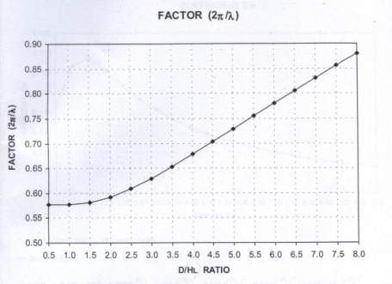

Figure 2: The factor 2π/λ for circular tanks [Figure 9.9 ACI 350.03]

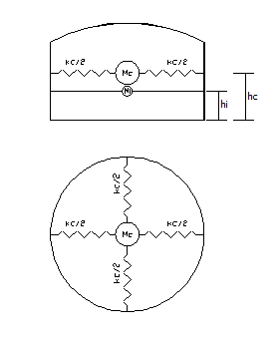

Figure 3: The Equivalent Mechanical Analogue for a Rigid Tank

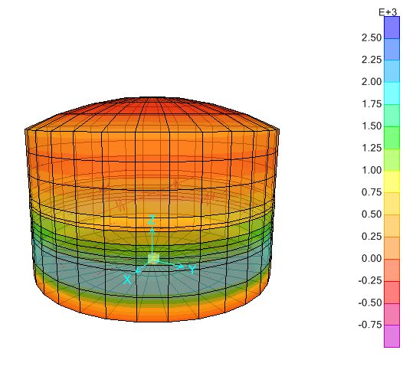
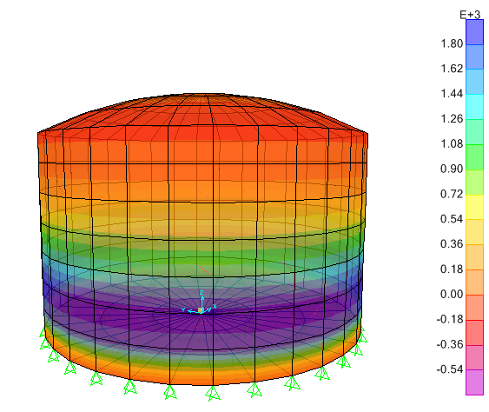
Figure 4: Comparison of Stress Distribution due to Static Loading [left] with the Response Spectrum Analysis [right]; [KN-m]

- Bibliography

- ACI 350.3-01/ACI 350.3R-01, 2001 Seismic Design of Liquid-Containing Concrete Structures and Commentary, American Concrete Institute, Detroit, Michigan, 2003.
- A. H. Helou, “Dynamics of Internal Waves in Cylindrical Tank”, Journal of Waterway, Port, Coastal and Ocean Engineering, ASCE Vol.111 No.2 March 1985.
- Habibullah, A., SAP 2000 12.0.0 "Static and Dynamic Finite Element Analysis of Structures", Computers and Structures Inc. Berkeley, California, 2008.
- Jaiswal, O.R., C. R. Durgesh, K. J. Sudhir. “Review of Code Provisions on Seismic Analysis of Liquid Storage tanks”, Document No. IITK-GSDMA-EQ04-V1.0.
- Kianoush, M.R. Tso, W.K, and Hamidi, M. “Behavior of Concrete Liquid Structures Subjected to Seismic loading”,
- Munshi, J.A., Legatos, N.A “Seismic design of liquid-containing concrete structures per ACI Standard 350.3”, 2003 Pacific Conference on Earthquake Engineering.
- Valestos, A.S. and Yang, J. Y., “Dynamics of Fixed-Base liquid Storage Tanks”, Proceedings of US-Japan Seminar for Earthquake Engineering Research with Emphasis on Life Line Systems, Tokyo, Japan, November 1976.
- Yang, S. Y., Dynamic Behavior of Fluid-Tank Systems, Ph.D. Dissertation, Rice university, Houston, Texas, March, 1976.

